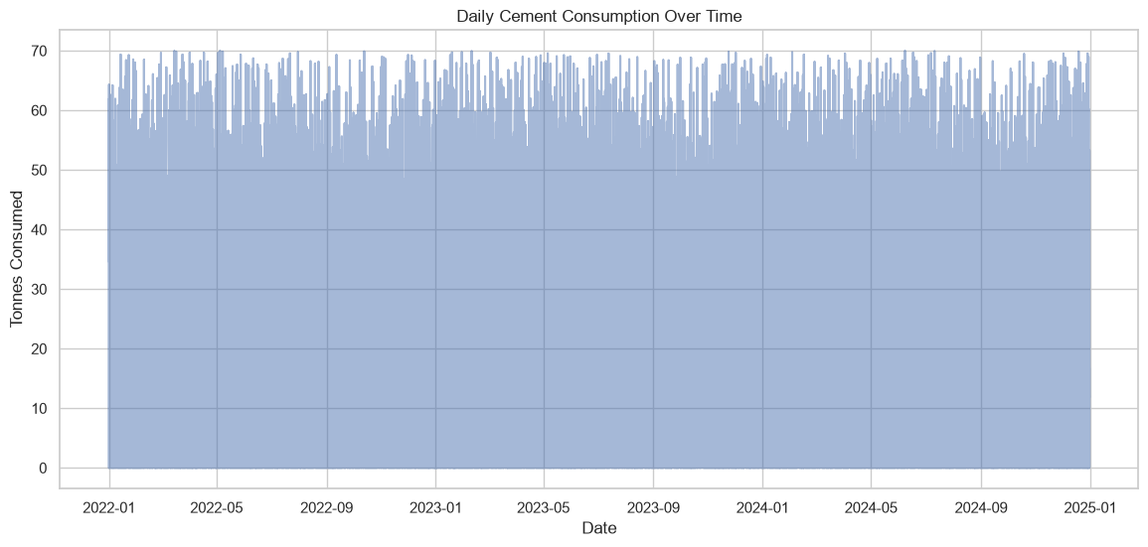
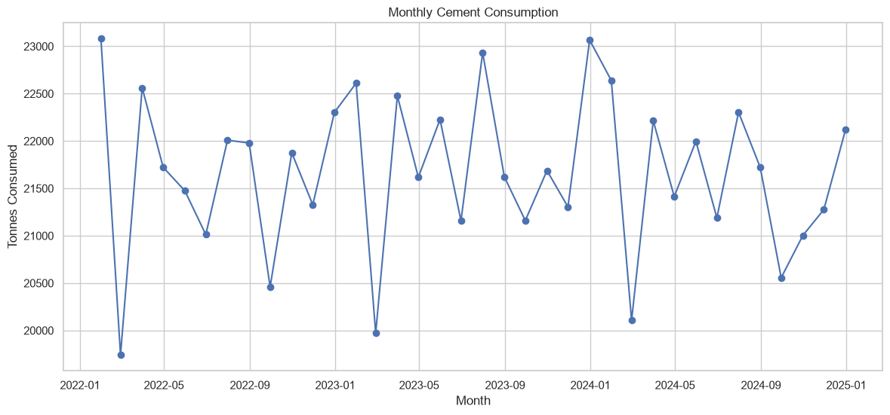
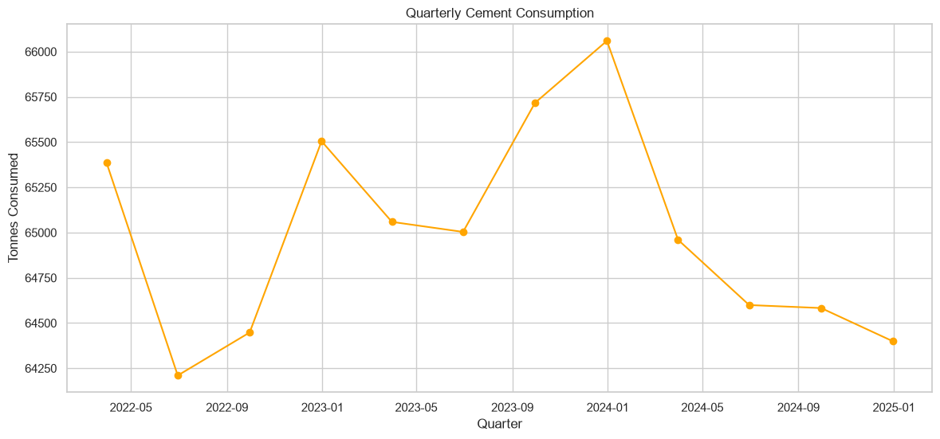

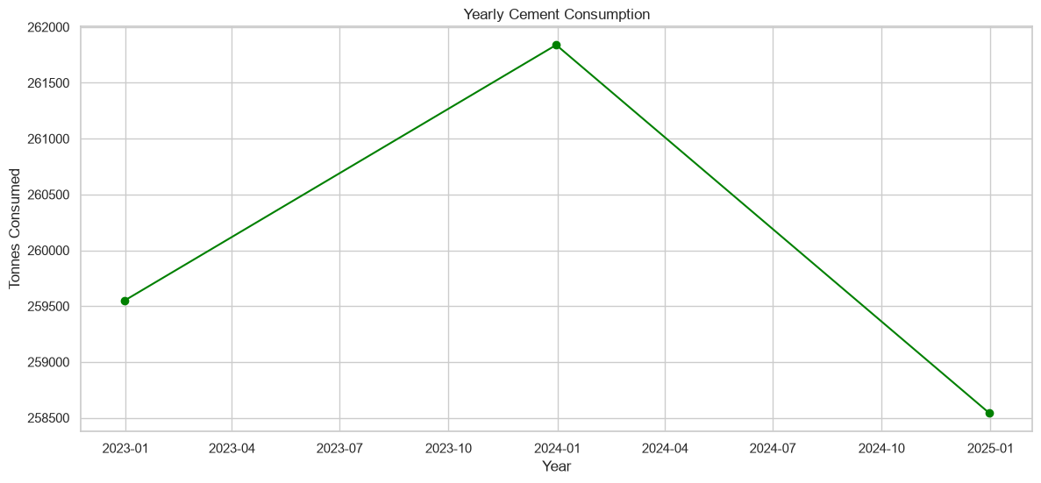

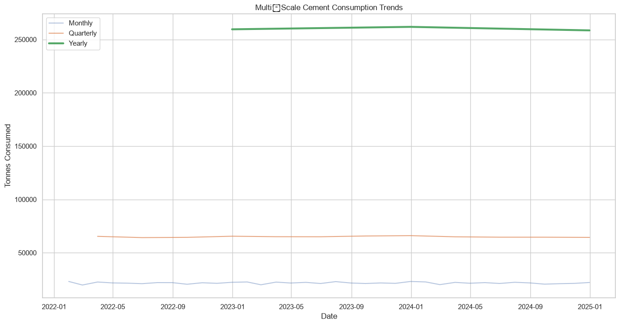
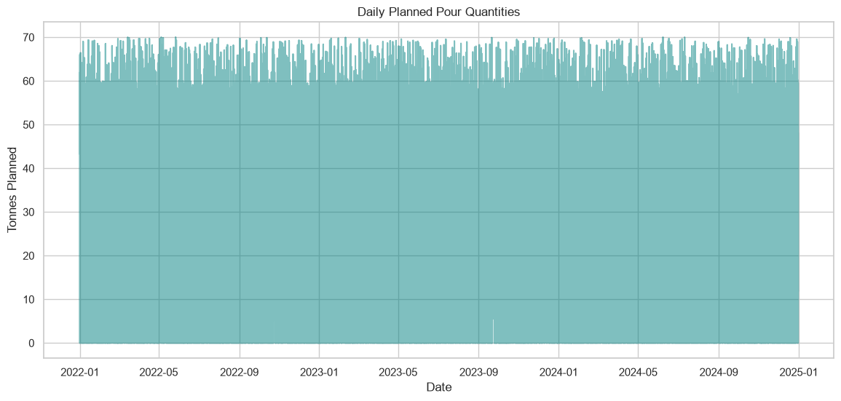

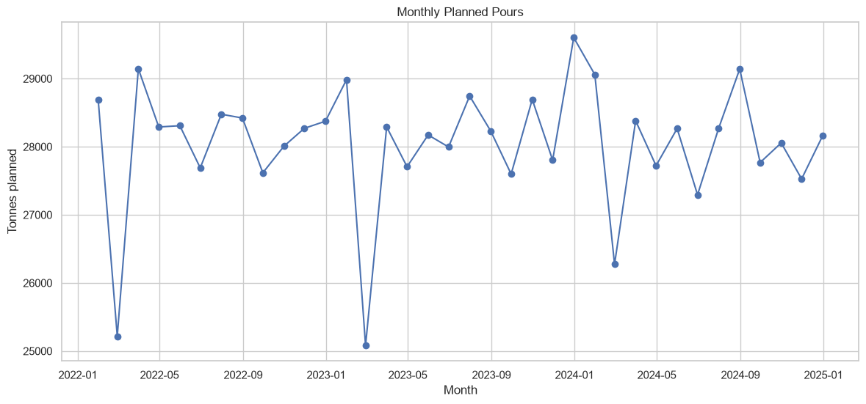

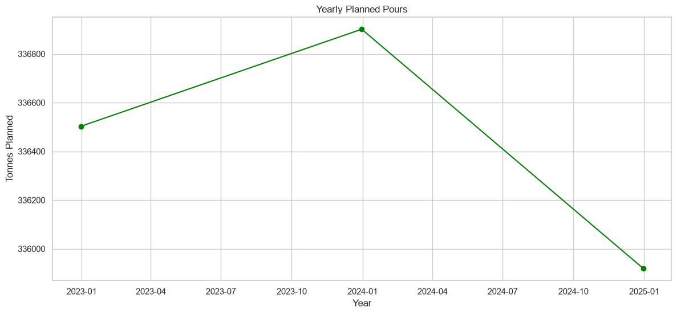

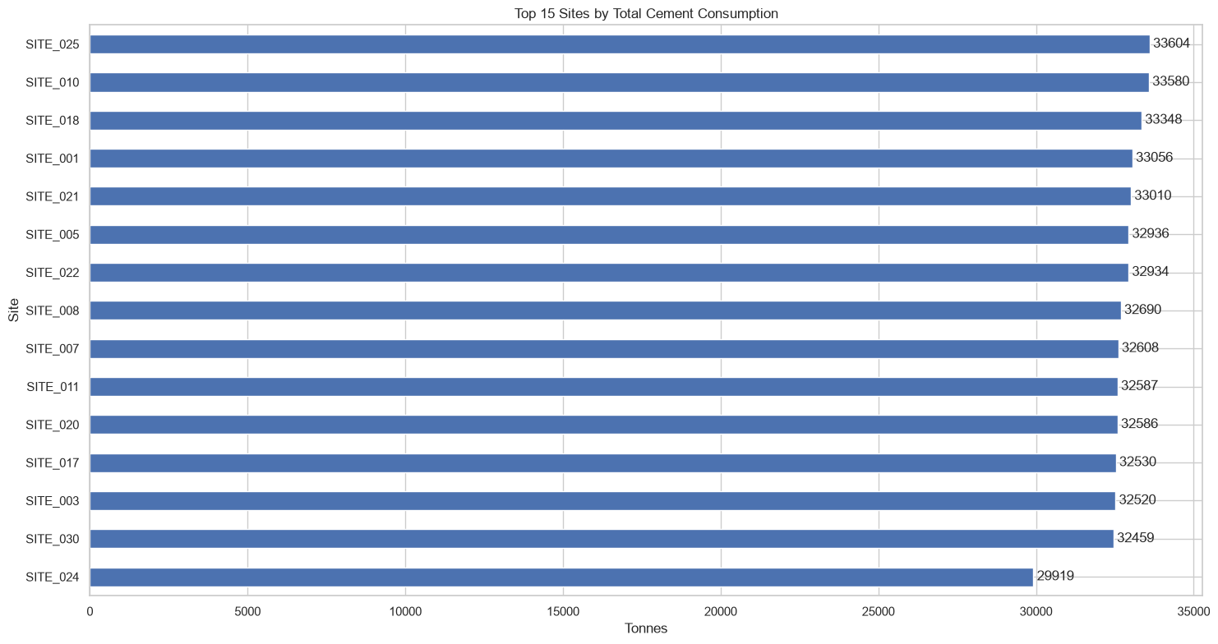

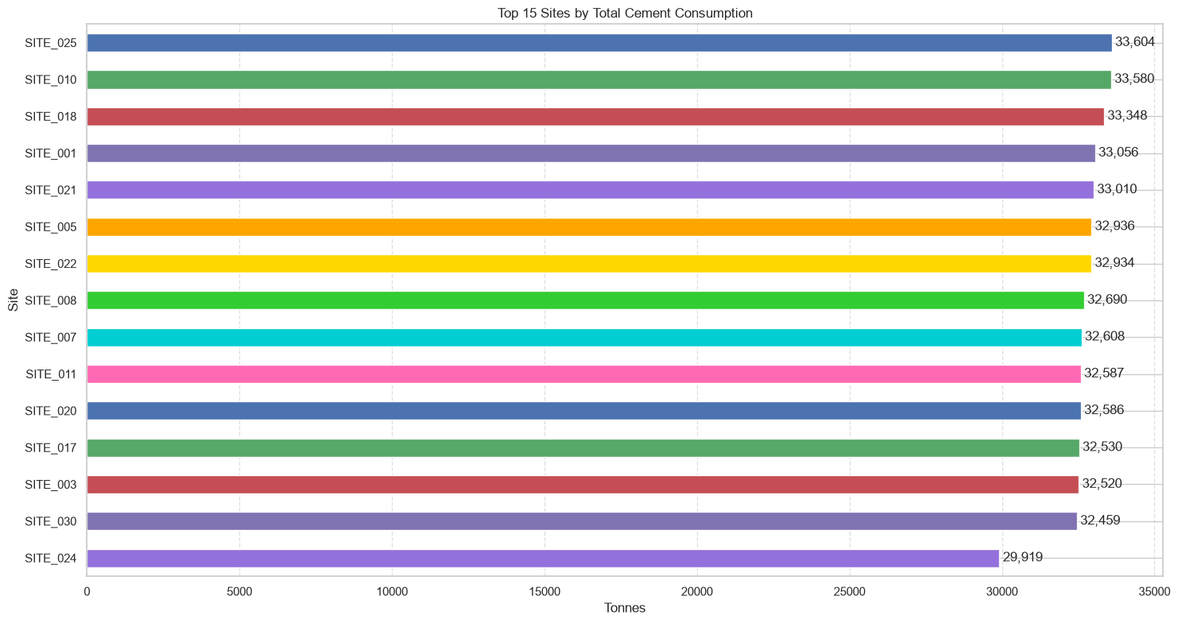

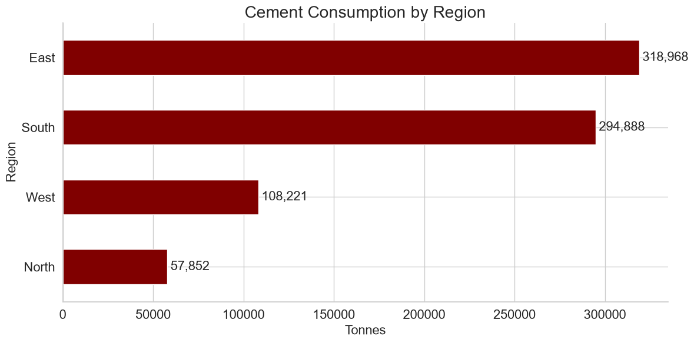

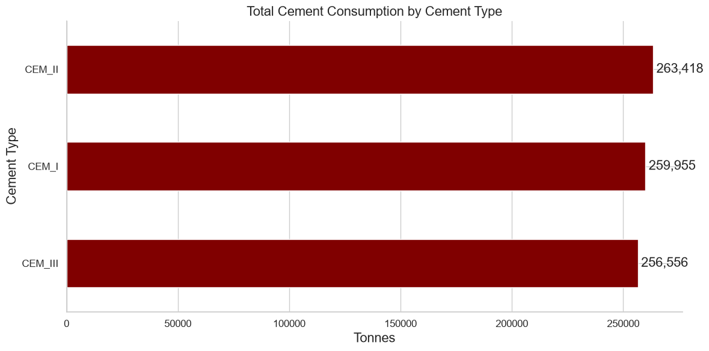

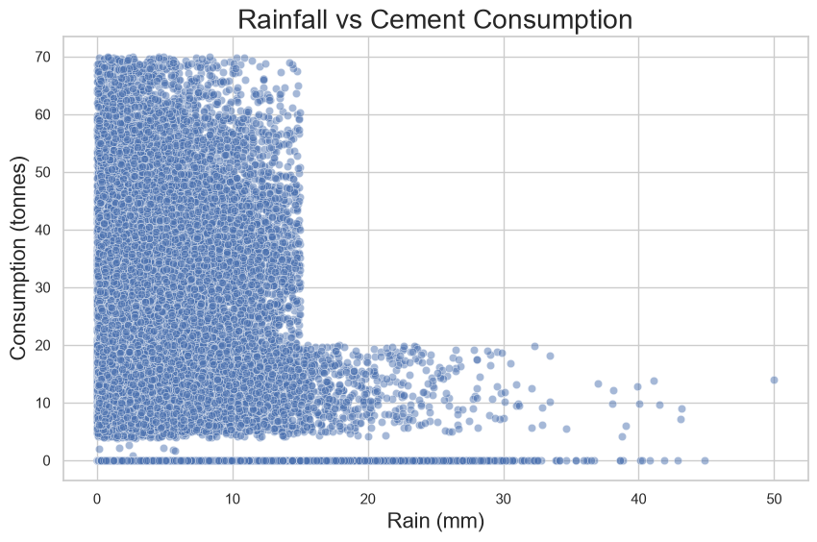

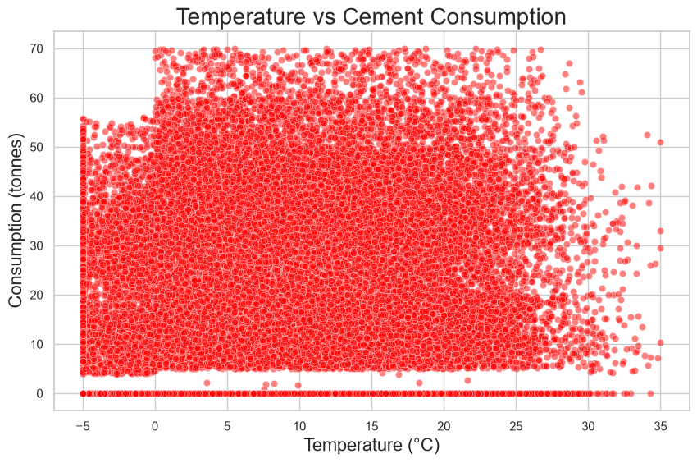

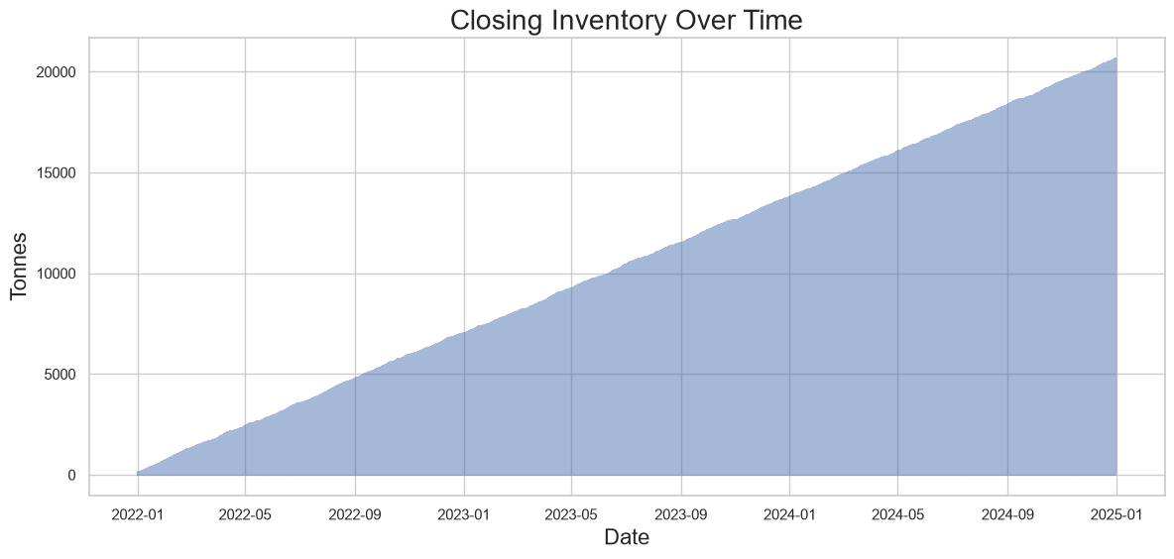

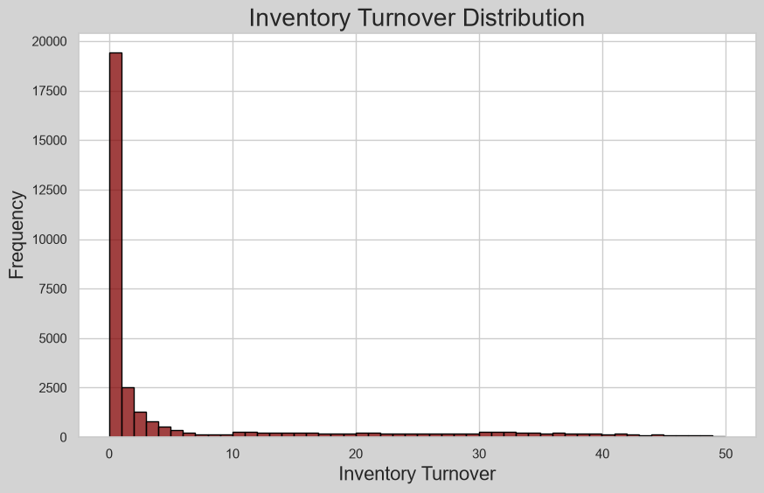

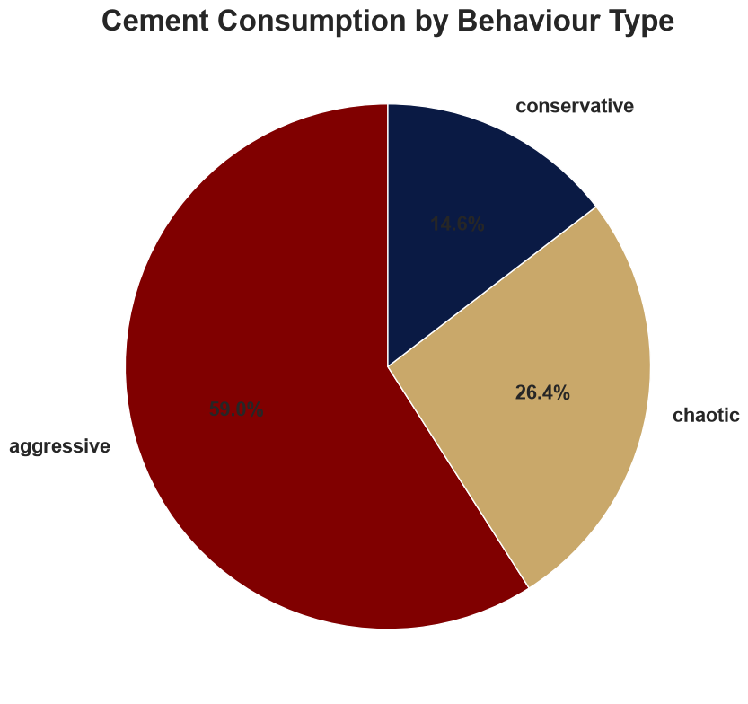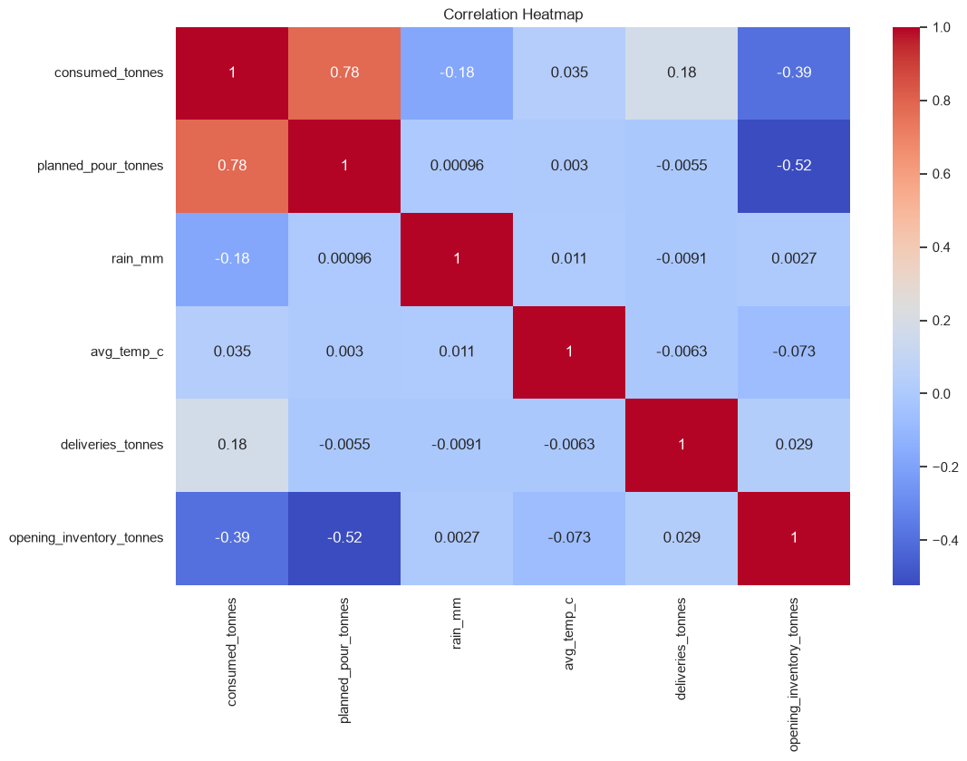

CHECKING OUTLIERS.
Box plot for consumed tonnes
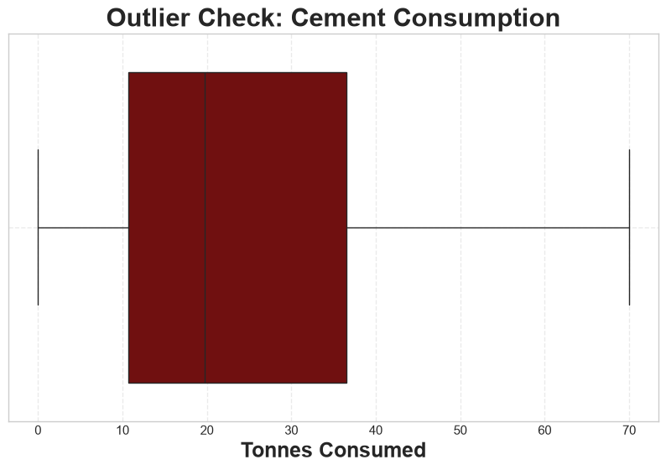

Time-series spike detection
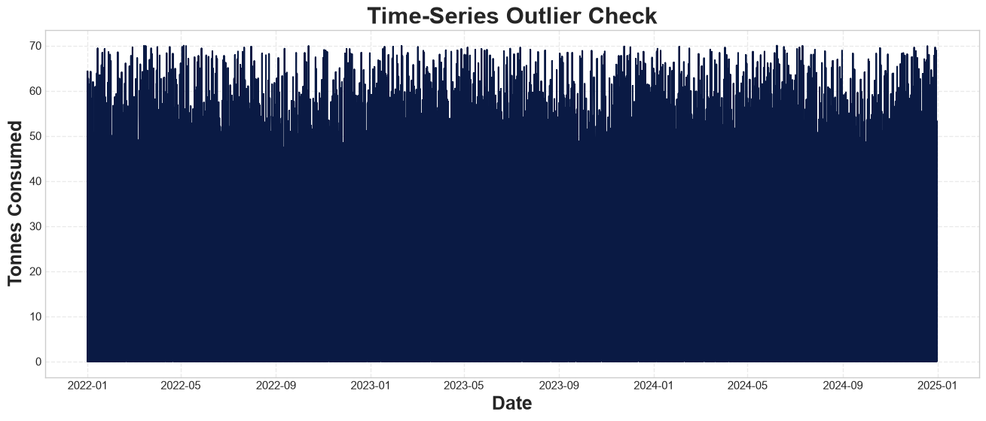

Statistical investigation –
- IQR Method (Industry Standard) - There was nothing in the (head - output)
- Z‑Score Method (Good for Normal-ish Data) - There was nothing in the (head - output)
SITE‑LEVEL OUTLIER DETECTION, There was nothing in the (head - output), - WEATHER‑RELATED OUTLIERS, There was nothing in the (head - output), -

Operational anomalies/outliers
site_id | cement_type | planned_pour_tonnes | consumed_tonnes | opening_inventory_tonnes | deliveries_tonnes | closing_inventory_tonnes | rain_mm | avg_temp_c | expected_closing | region | silo_capacity | behavior | inventory_turnover | z_score
date
2022-01-01 | SITE_014 | CEM_I | 0.00 | 0.0 | 41.51 | 21.18 | 62.69 | 1.93 | 12.87 | 62.69 | West | 230 | chaotic | 0.0 | -1.408057
2022-01-01 | SITE_005 | CEM_II | 42.42 | 0.0 | 79.21 | 46.97 | 126.18 | 29.77 | 23.52 | 126.18 | South | 230 | aggressive | 0.0 | -1.408057
2022-01-02 | SITE_007 | CEM_III | 0.00 | 0.0 | 20.53 | 20.41 | 40.94 | 0.85 | 6.16 | 40.94 | East | 485 | aggressive | 0.0 | -1.408057
2022-01-02 | SITE_026 | CEM_II | 0.00 | 0.0 | 41.66 | 43.38 | 85.04 | 4.31 | 13.48 | 85.04 | South | 369 | chaotic | 0.0 | -1.408057
2022-01-02 | SITE_021 | CEM_III | 0.00 | 0.0 | 36.88 | 10.05 | 46.93 | 3.34 | 2.92 | 46.93 | East | 180 | aggressive | 0.0 | -1.408057

Negative inventory adjustments – (There was nothing in the (head)- output)
Sudden inventory jumps
site_id | cement_type | planned_pour_tonnes | consumed_tonnes | opening_inventory_tonnes | deliveries_tonnes | closing_inventory_tonnes | rain_mm | avg_temp_c | expected_closing | region | silo_capacity | behavior | inventory_turnover | z_score
date
2022-01-01 | SITE_008 | CEM_III | 48.63 | 48.63 | 20.33 | 30.38 | 2.08 | 6.33 | 2.46 | 2.08 | West | 260 | aggressive | 2.279887 | 1.478639
2022-01-03 | SITE_027 | CEM_II | 14.00 | 14.00 | 93.59 | 37.89 | 117.48 | 2.80 | 16.46 | 117.48 | North | 314 | conservative | 0.148007 | -0.577011
2022-01-04 | SITE_020 | CEM_I | 32.75 | 32.75 | 29.76 | 44.11 | 41.12 | 0.79 | 11.10 | 41.12 | South | 363 | aggressive | 1.064694 | 0.535996
2022-01-04 | SITE_009 | CEM_I | 10.93 | 10.93 | 109.18 | 36.52 | 134.77 | 2.70 | 6.71 | 134.77 | East | 352 | conservative | 0.099201 | -0.759248
2022-01-05 | SITE_020 | CEM_II | 47.43 | 47.43 | 41.12 | 31.12 | 24.81 | 2.68 | 13.94 | 24.81 | South | 363 | aggressive | 1.126068 | 1.407407

Planned pours but no consumption
site_id | cement_type | planned_pour_tonnes | consumed_tonnes | opening_inventory_tonnes | deliveries_tonnes | closing_inventory_tonnes | rain_mm | avg_temp_c | expected_closing | region | silo_capacity | behavior | inventory_turnover | z_score
date
2022-01-01 | SITE_005 | CEM_II | 42.42 | 0.0 | 79.21 | 46.97 | 126.18 | 29.77 | 23.52 | 126.18 | South | 230 | aggressive | 0.0 | -1.408057
2022-01-04 | SITE_025 | CEM_I | 35.89 | 0.0 | 2.00 | 22.89 | 24.89 | 23.79 | 11.17 | 24.89 | South | 261 | aggressive | 0.0 | -1.408057
2022-01-08 | SITE_013 | CEM_II | 46.40 | 0.0 | 34.63 | 0.00 | 34.63 | 16.66 | 8.74 | 34.63 | South | 154 | chaotic | 0.0 | -1.408057
2022-01-12 | SITE_018 | CEM_III | 53.60 | 0.0 | 0.00 | 20.57 | 20.57 | 25.54 | 6.16 | 20.57 | East | 152 | aggressive | 0.0 | -1.408057
2022-01-13 | SITE_007 | CEM_I | 53.75 | 0.0 | 2.51 | 37.96 | 40.47 | 15.31 | 5.37 | 40.47 | East | 485 | aggressive | 0.0 | -1.408057

